**Library management system:**

~User Documentation

Developers:

* Mayank Baranwal: 170101084
* Aditya Vardhan Gara: 170101003
* Deepak Gami: 170101020
* Shri Raam Reddy: 170101016
* Sourabh Jangir: 170101067
* Abhishek Jaiswal: 170101002

**About LMS:**

LMS (library management system) is aimed to develop a software for a library system to make users and admin interaction with ease and to manage library system more conveniently. Our LMS is a modified system for library management with lots newly added features such as E-books, Discussion room, recommend books and improvised admin rights. Our LMS is an improvised library management system.

**Getting into LMS:**

First interface (search page):

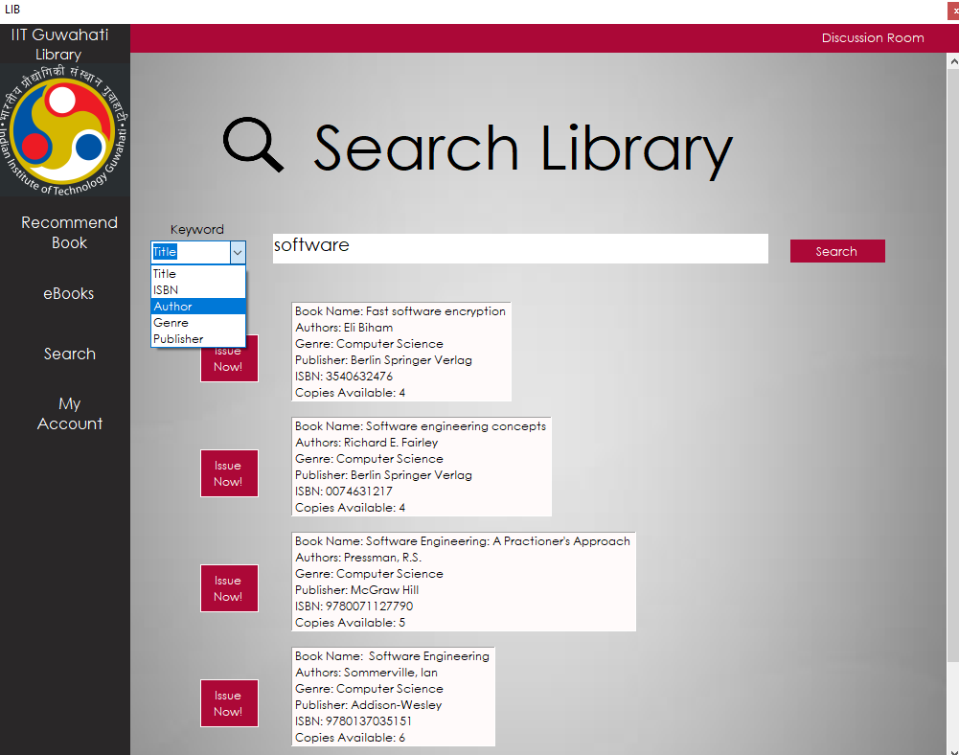

*Search by different fields*

*Search results are shown*

This is the first interface displayed on running our application. This page let users (even for the people not logged into our LMS system) to browse through books in the library. Our browsing part made user easy to search through books on basis of title, genre, author etc, this makes users more convenient for browsing through books. The books that are matched with the searching are displayed below.

Moving through functionalities:

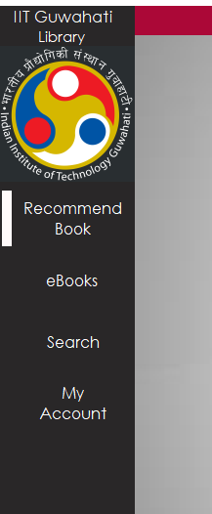

*Other fields offered*

As we can see in the side panel other provided functionalities of the LMS recommend books, Ebooks, My account. Getting into more details:

Recommend books:

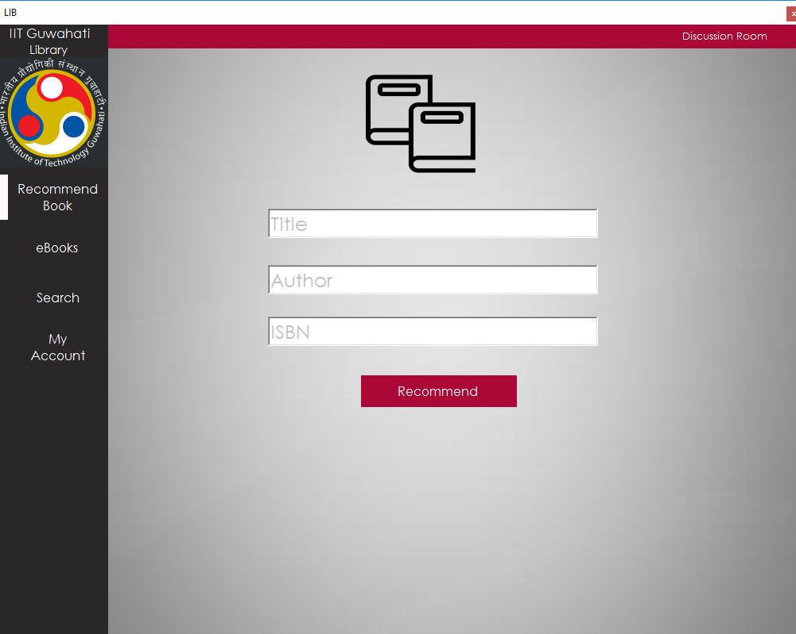

A system without feedback is not a complete system. There is a strong need to know the user requirements. Hence our LMS let the users to recommend books to the admin so that admin can know user requirements more deliberately. User can recommend them on the basis of title, author and ISBN.

E books:

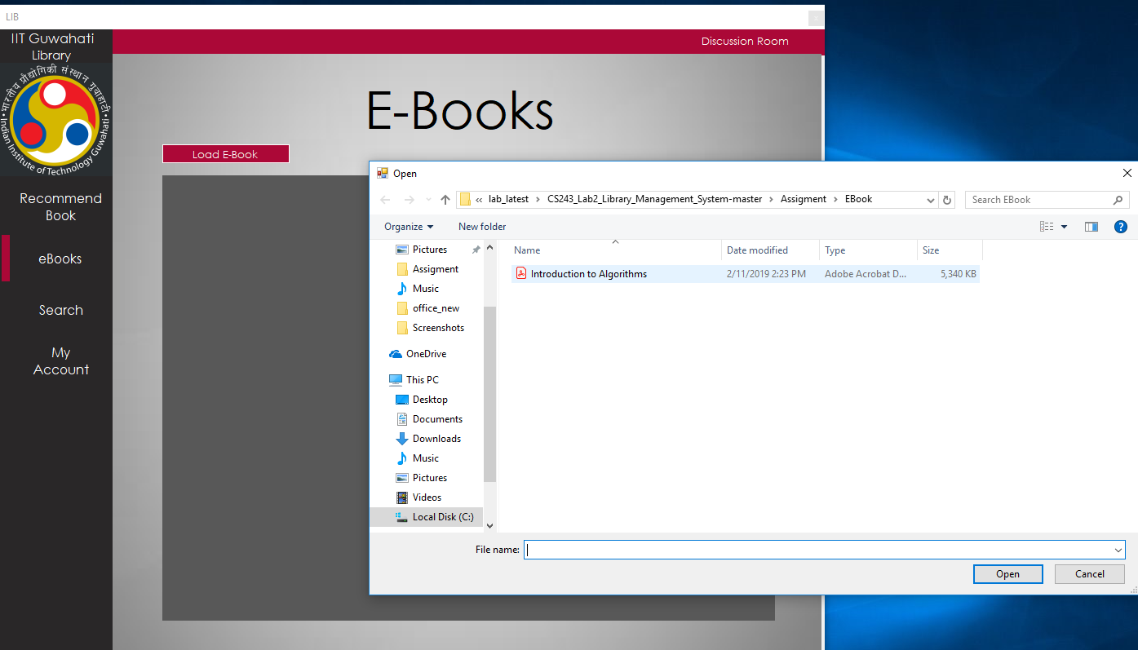

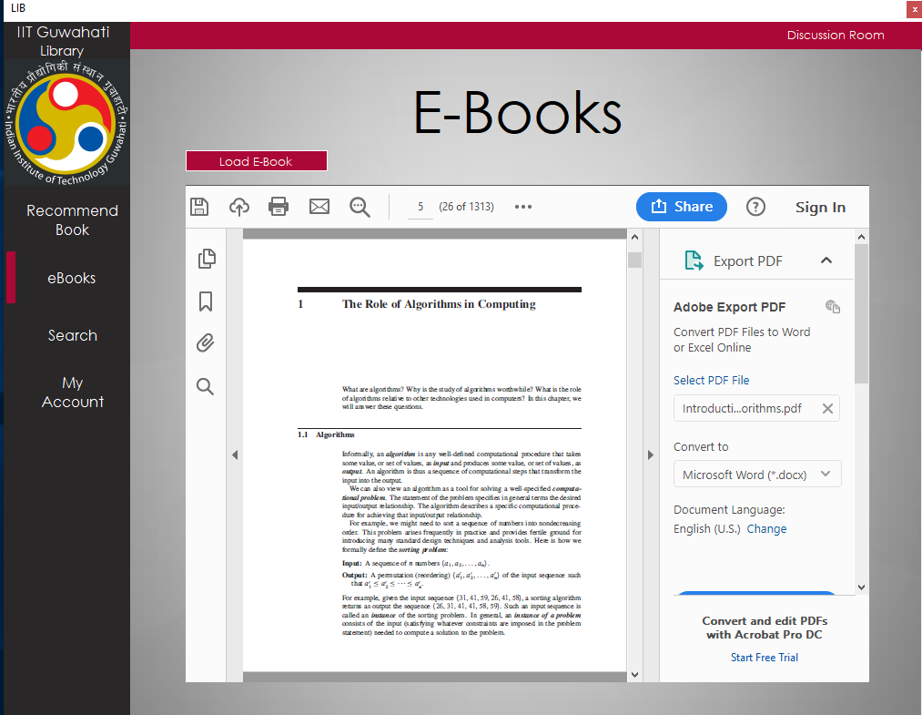

Providing books to all required users is not a simple thing. A library may not have such a large number of copies. So our LMS let the users to access Ebooks available to download from the application.

Discussion room:

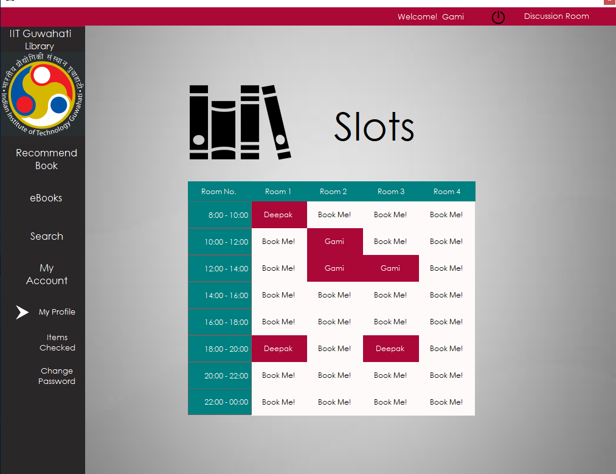

It is good to have a group to share ideas and debate on a topic. So we thought of developing a discussion room to book a plot for discussing about a topic in our library. A logged in user can book a plot for discussion room in the application. The application shows available slots 1 hour each and let user to book for them in advanced.

Logging into account:

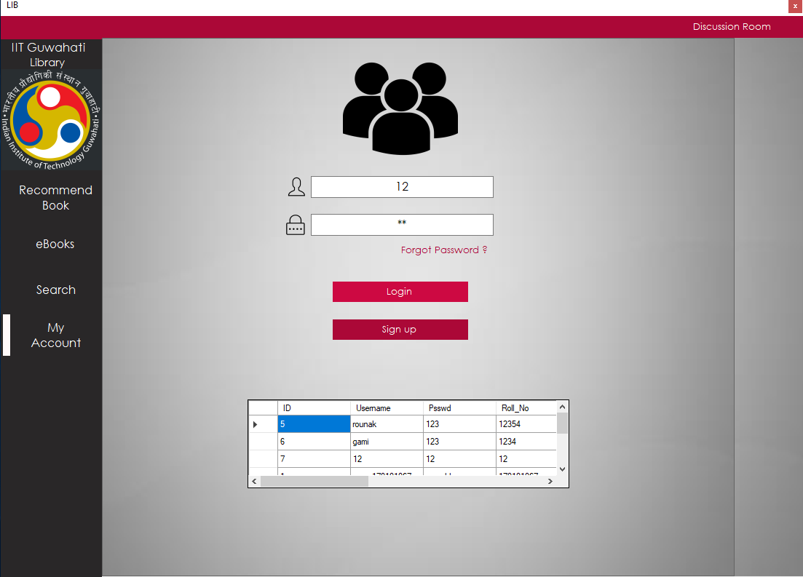

This page let the users to logging into their account to manage their account or to issue a book from library.

* My profile:

This page let the users to view their details

* Items checked:

This prompt keeps track of previous history of the users books issued by him and books to be returned.

* Change password:

It’s a good idea to change password for more user privacy and security. So, our system let the user to update his password whenever he needs.

Creating a new account:

This page let the new users to sign up into our LMS with their credentials. They can upload their image by clicking on add image. He can sign up as a student or faclty or as a admin.

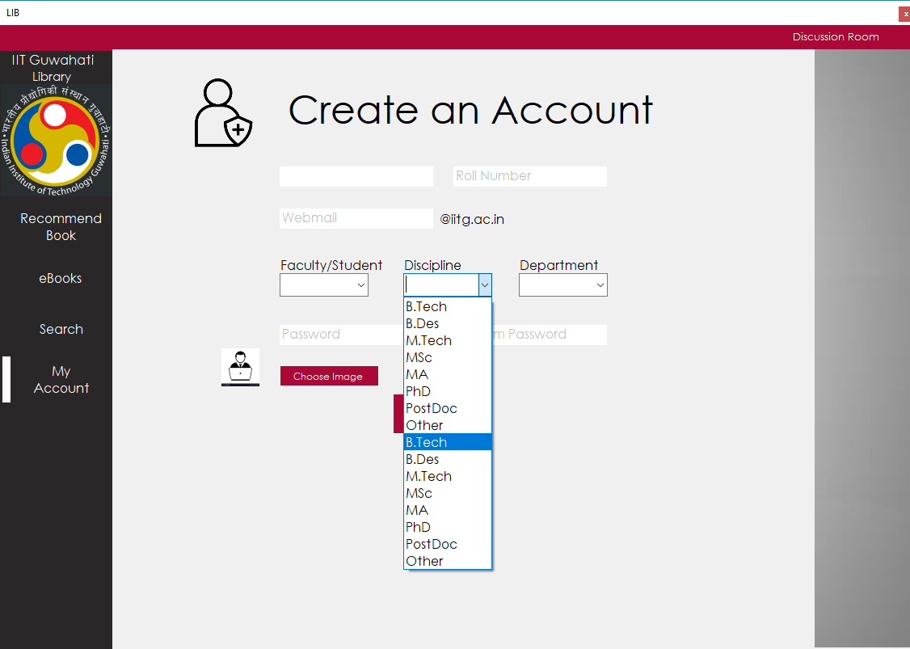

Logging into LMS as admin:

The rights and tasks of a admin is quietly different from that of user. They have special rights in managing database of LMS system such as adding books, removing books, and knowing book and user details and to know recommended books by the users.

Adding and removing books:

Admin must have rights to manage database of books, in case a new book added he should be able to add a book or can remove a book incase if it is lost. So, if a person logged in as admin he should be able to add book or can remove it with this feature.

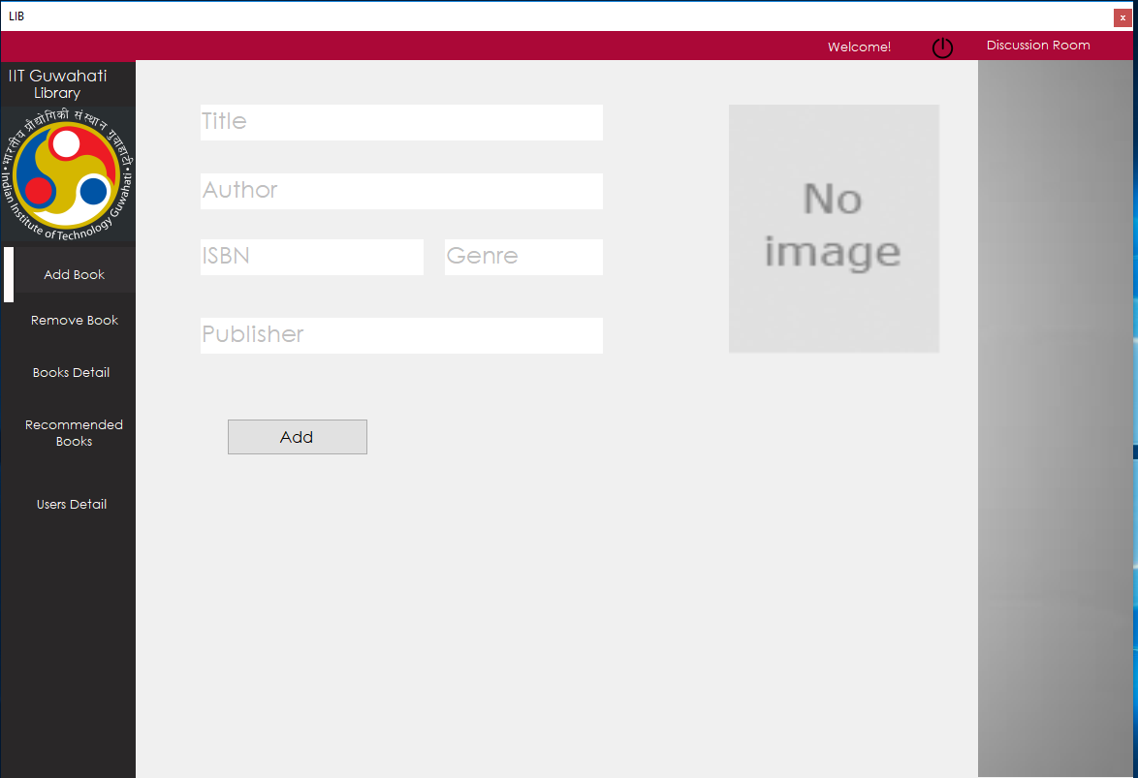

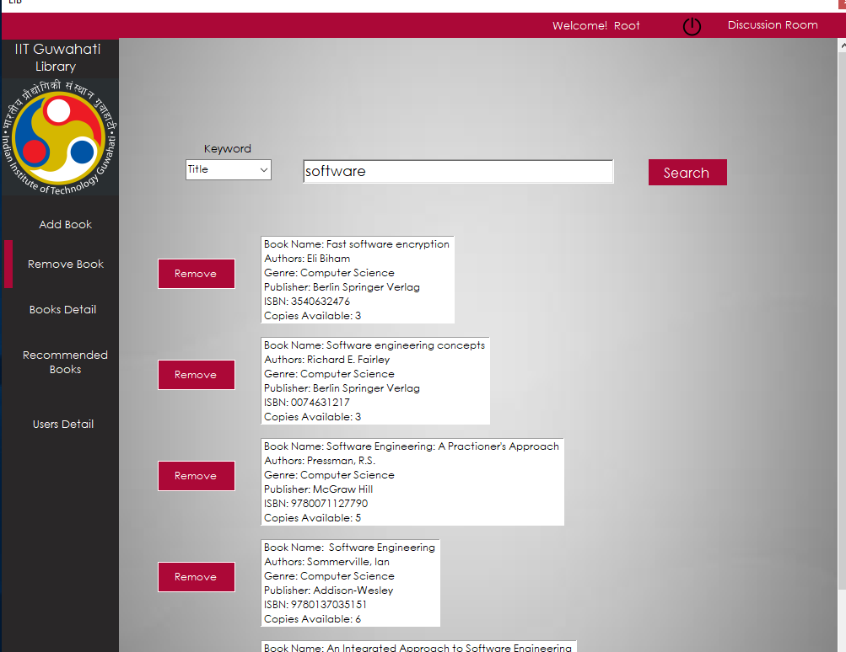

Recommended books:

This lets the admin to know what books are recommended by the users such that he can improvise the library system.

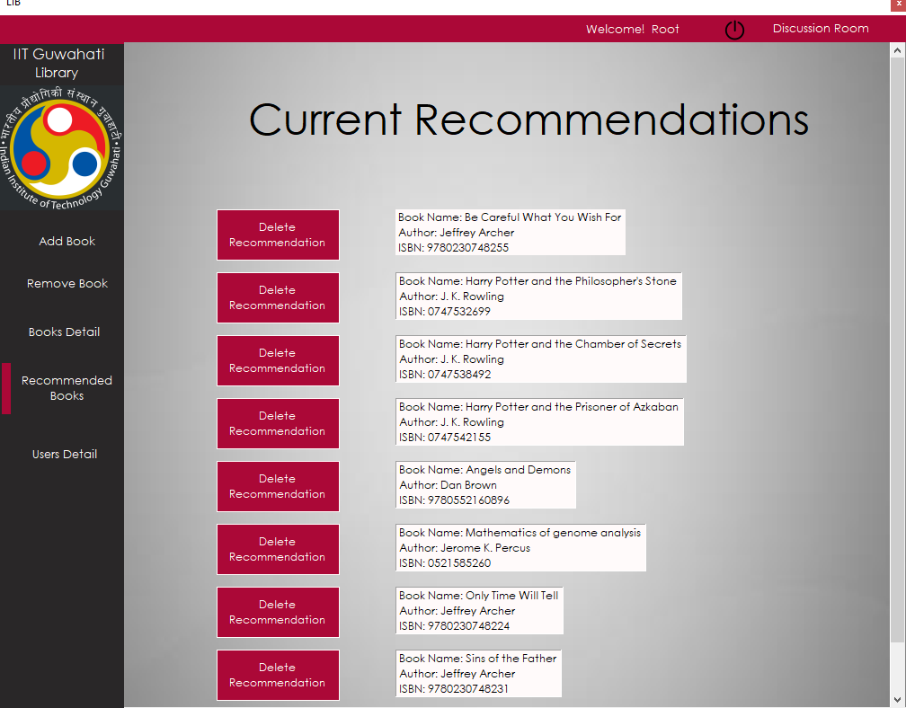

Knowing user and book details:

This let the admin to provide the right to admin to access the details of every book and every user in library management system such that he can manage the library more efficiently.

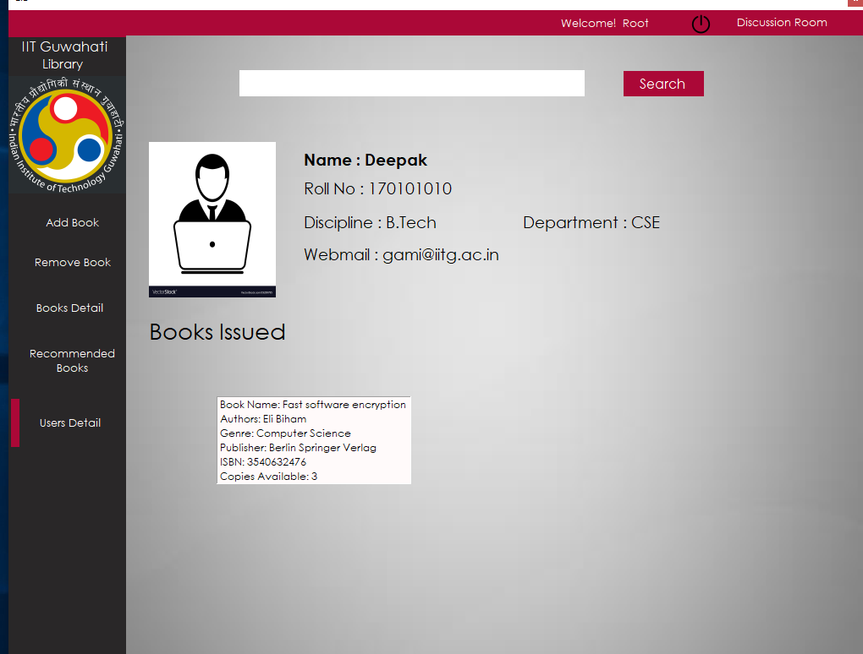

*Log out*

*Close the application*

Logging out:

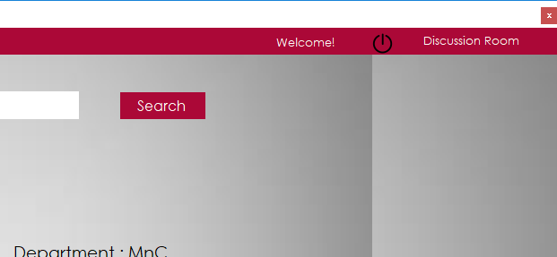

By clicking on logout button you can log out from your account. Right upper corner red close button closes or stops the application.